Task 2: Data Visualization and Storytelling

Objective: Create visualizations that convey a compelling story.
Tools Used: Power BI Desktop.
Dataset Used: Superstore Dataset.xlsx
STORYLINE: "Uncovering business insights into sales, profit, and customer behaviour to drive business decisions."
Slide-1: Executive summary - Superstore sales performance overview.
- Introduced the overall health of the superstore.
- Used Key Performance Indicator (KPI) cards to display the most critical metrics upfront.
- Total Sales.
- Total Profit.
- Profit Margin.
- Sales YoY Growth.
- Total Transaction.
- Visualized the trend of Regional Sales over Order Date, Sales over Segment bar chart, Sales over Category bar chart, Sales by Region Treemap and Ship mode transactions. This immediately show if the business is growing or declining over time.
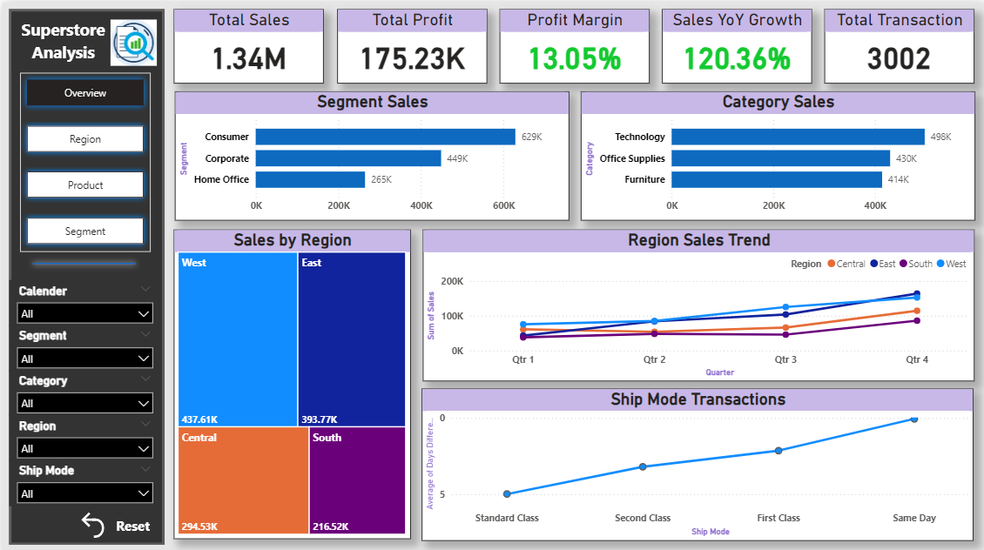
Slide-2: Regional performance analysis - Regional sales and profit breakdown.
- The Western region is a profit powerhouse, while the Central region's profitability is a major concern.
- The West is a top performer in both sales and profits. In contrast, the Central region has low profit despite decent sales, indicating potential operational inefficiencies or aggressive discounting.
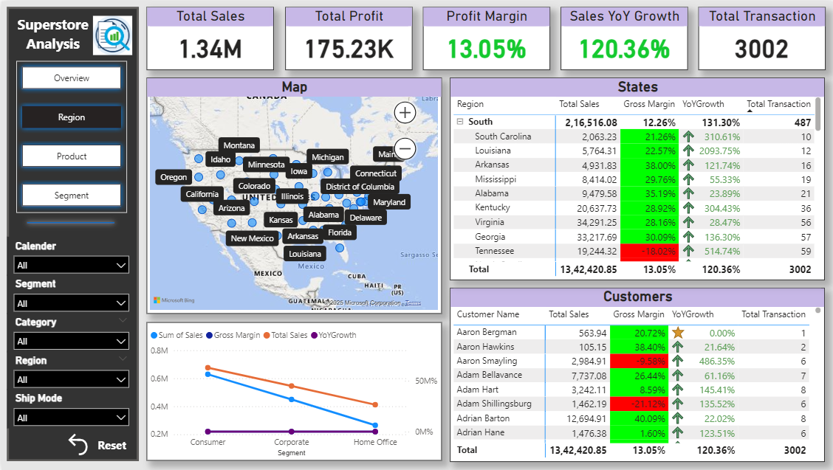

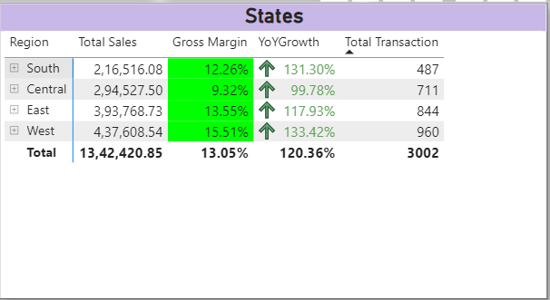

Slide-3: Product category deep dive - Sales and profit by product category.
- This page drills down into the product hierarchy, analyzing the performance of different categories and sub-categories to identify profit drivers and drains.
- Technology is the most profitable product category, while Furniture is consistently unprofitable.
- The Technology category is a star performer, accounting for a large portion of the store's profit. The Furniture category, however, is a loss-leader that requires a strategic review to address issues related to high costs or excessive discounts.
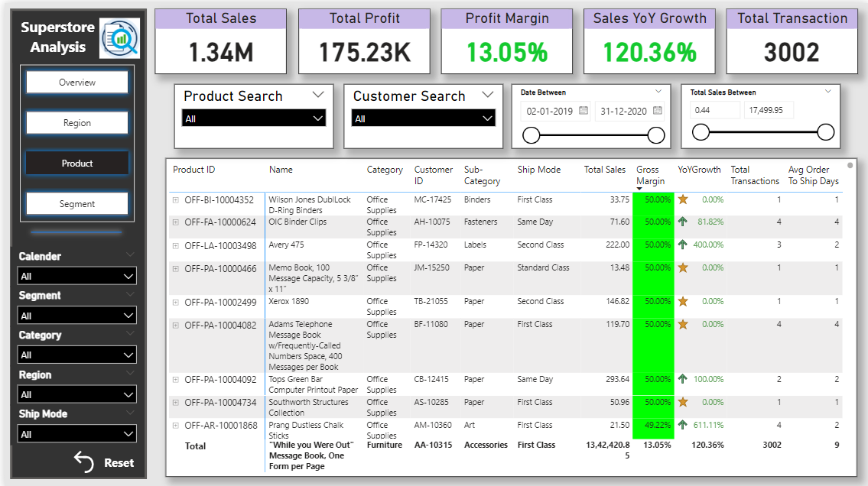

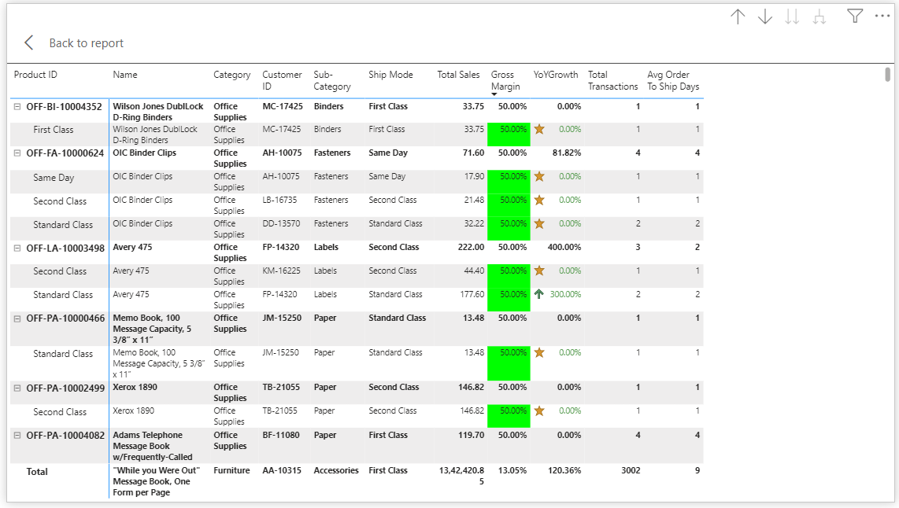
- A bar chart displaying Total Sales and Profit by Product Category. This visual shows the total sales and profit for each of the main categories: Technology, Furniture, and Office Supplies. And a detailed bar chart and treemap showing profit and gross margins for each sub-category.

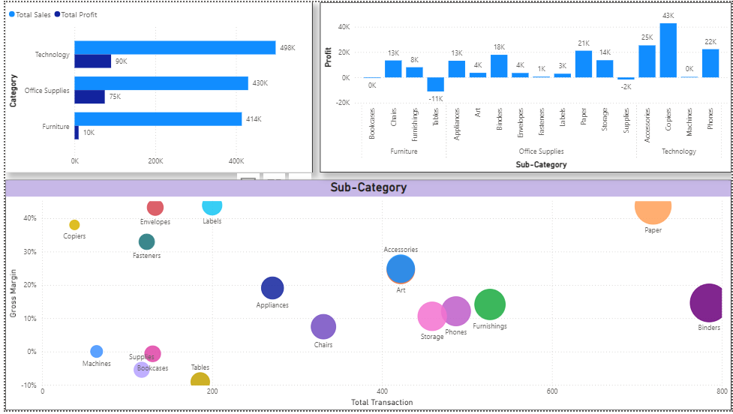

Slide-4: Customer segmentation and profitability - Customer segment analysis.
- This page focuses on the customer base and the impact of different shipping modes on profitability.
- The Donut chart Visualizes the contribution of different customer segments—Consumer, Corporate, and Home Office—to the overall sales and profit. Here we can see that the Consumer segment is the most profitable and loyal.
- The two table shows the top 10 states and top 6 customers.
